HU Extension **Assignment 03** E-63 Big Data Analytics

**Problem 1**

Create S3 bucket

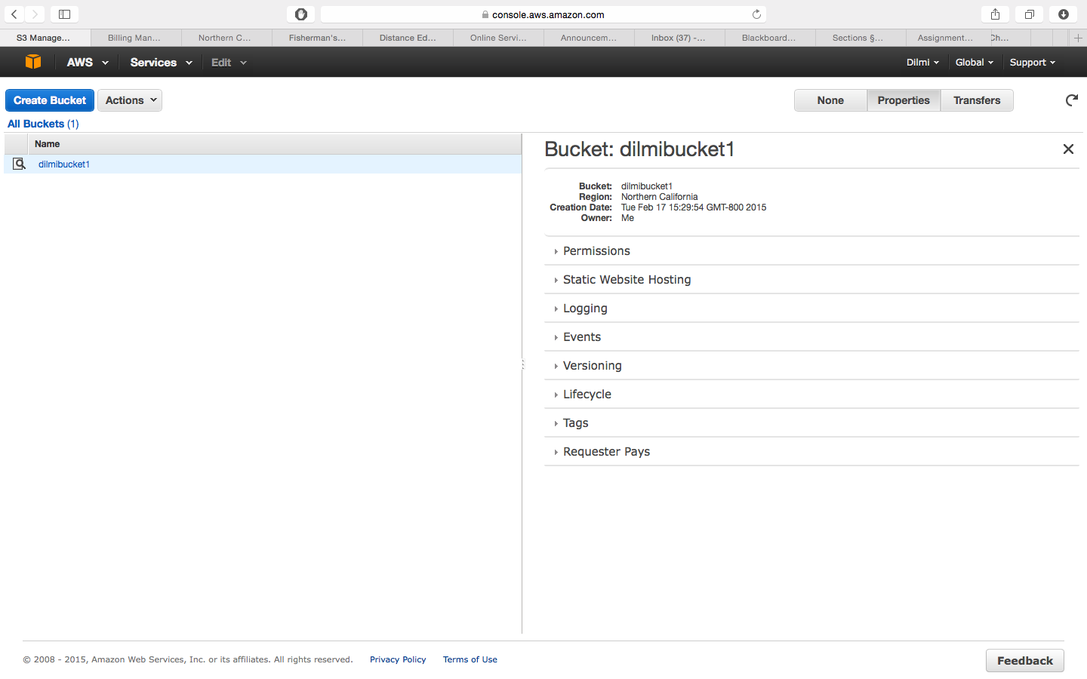

Enable versioning

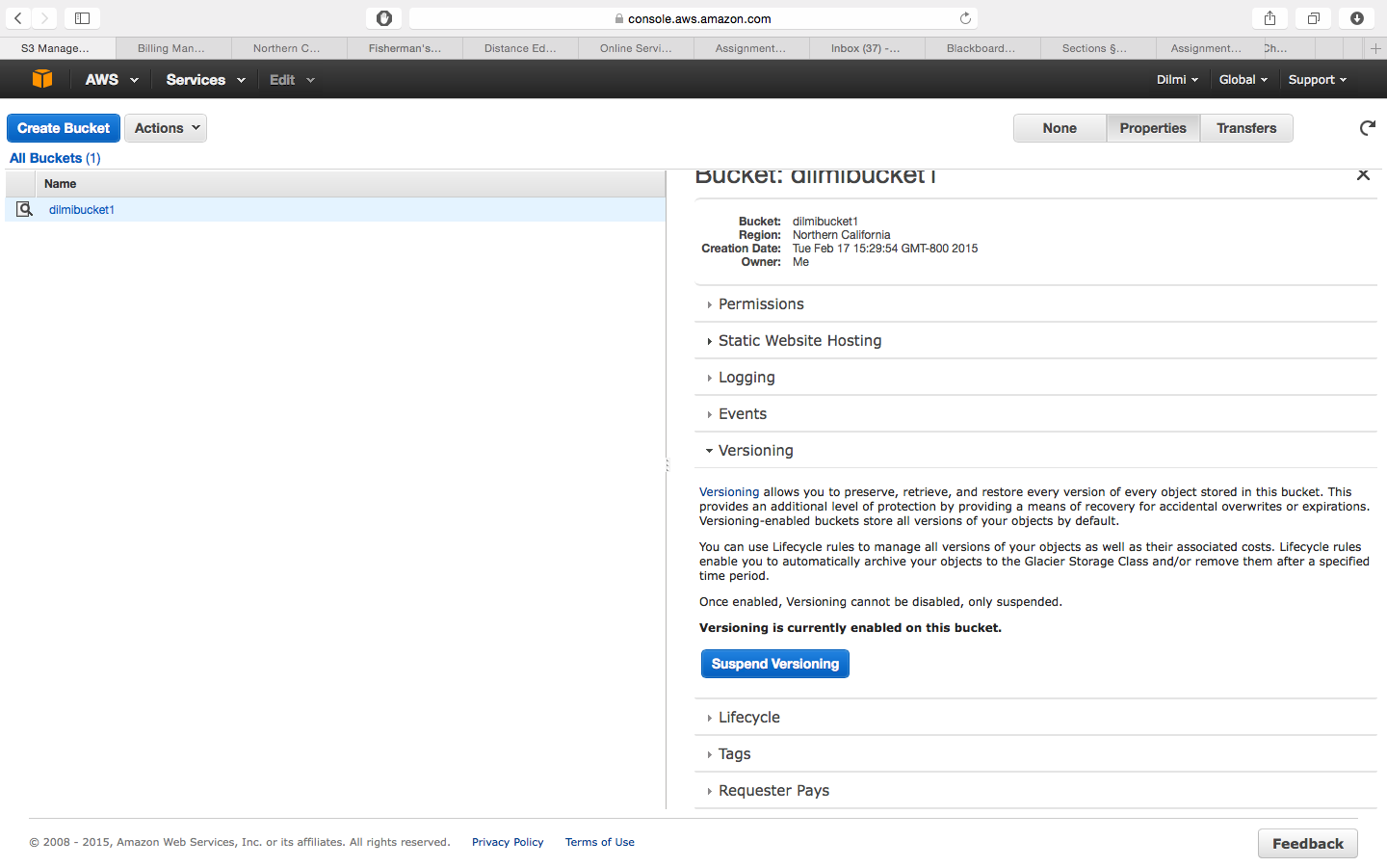

Upload file

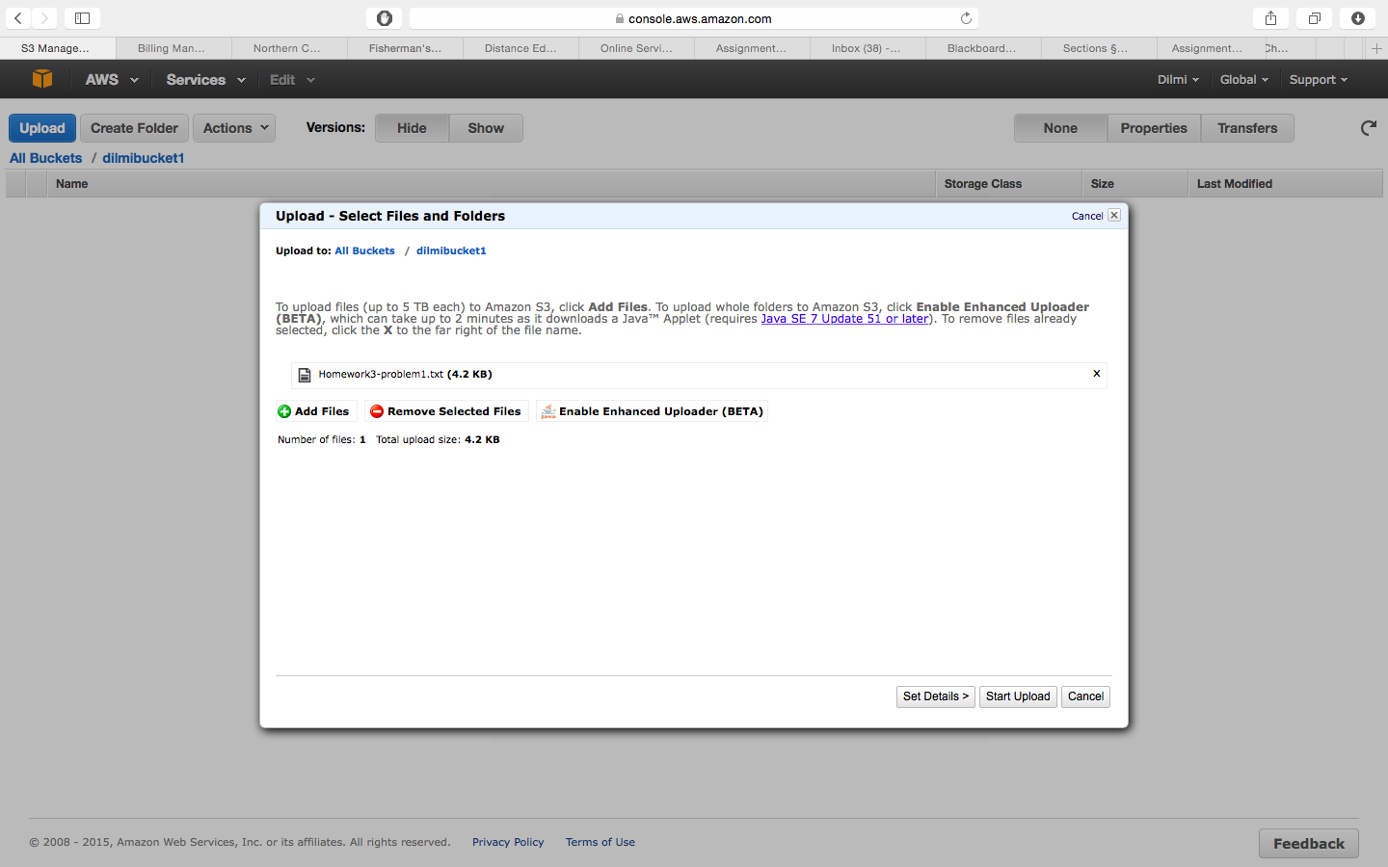

Upload modified file

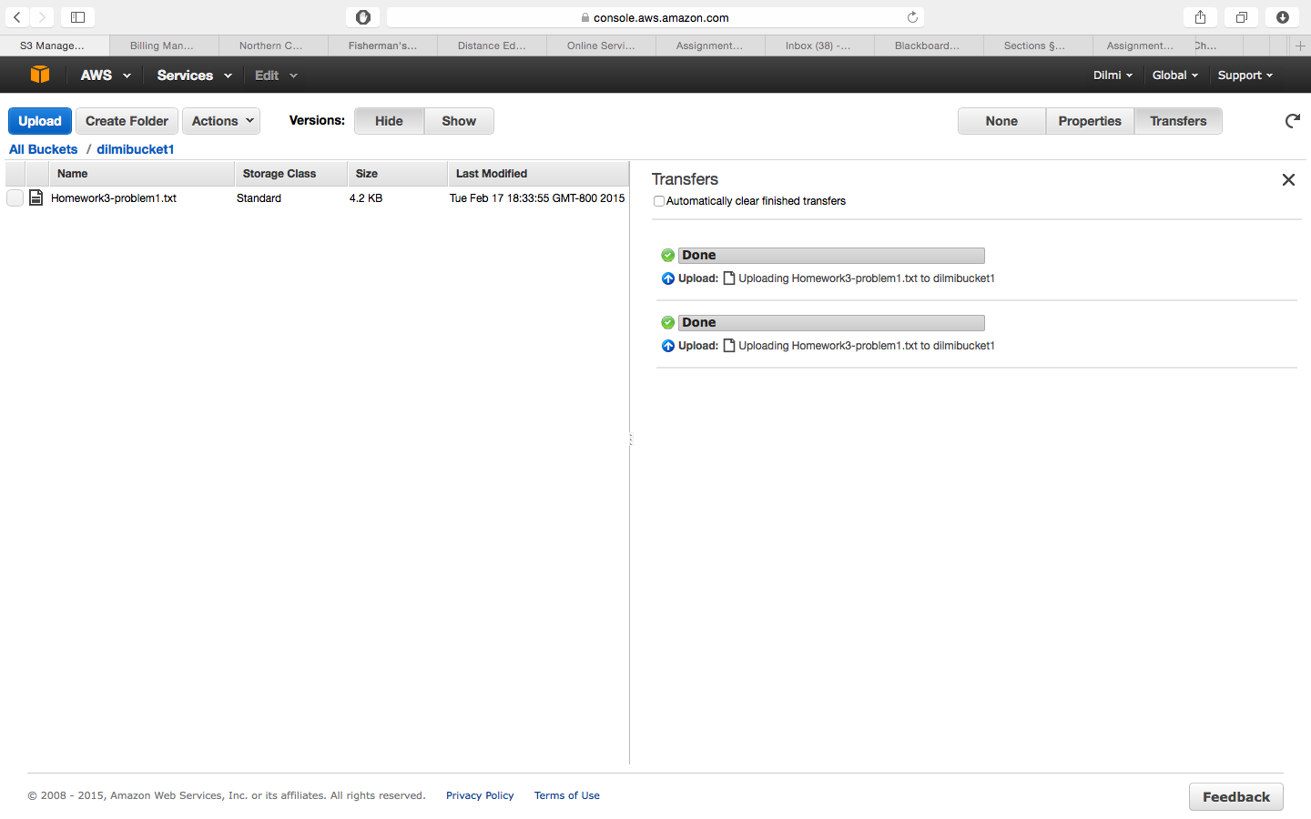

Both versions can be retrieved

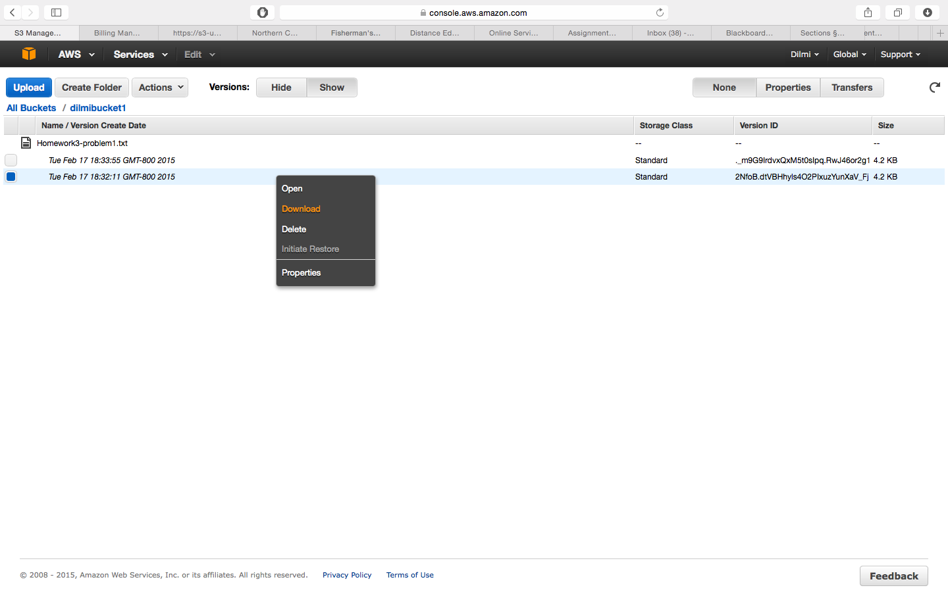

Permission for everyone to view the bucket

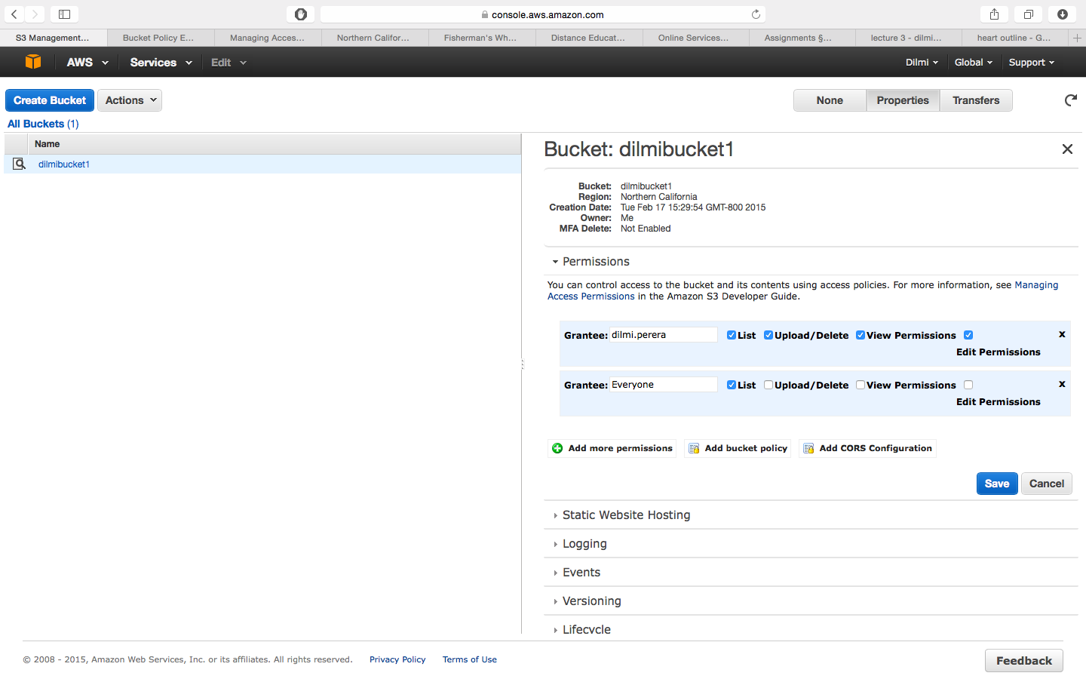

Link to download image

<https://s3-us-west-1.amazonaws.com/dilmibucket1/heart.jpg>

**Problem 2**

**Create EC2**

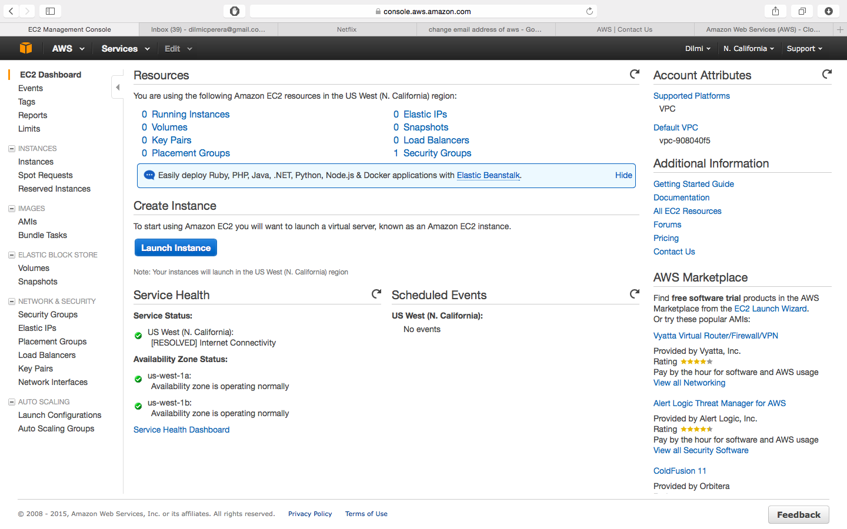

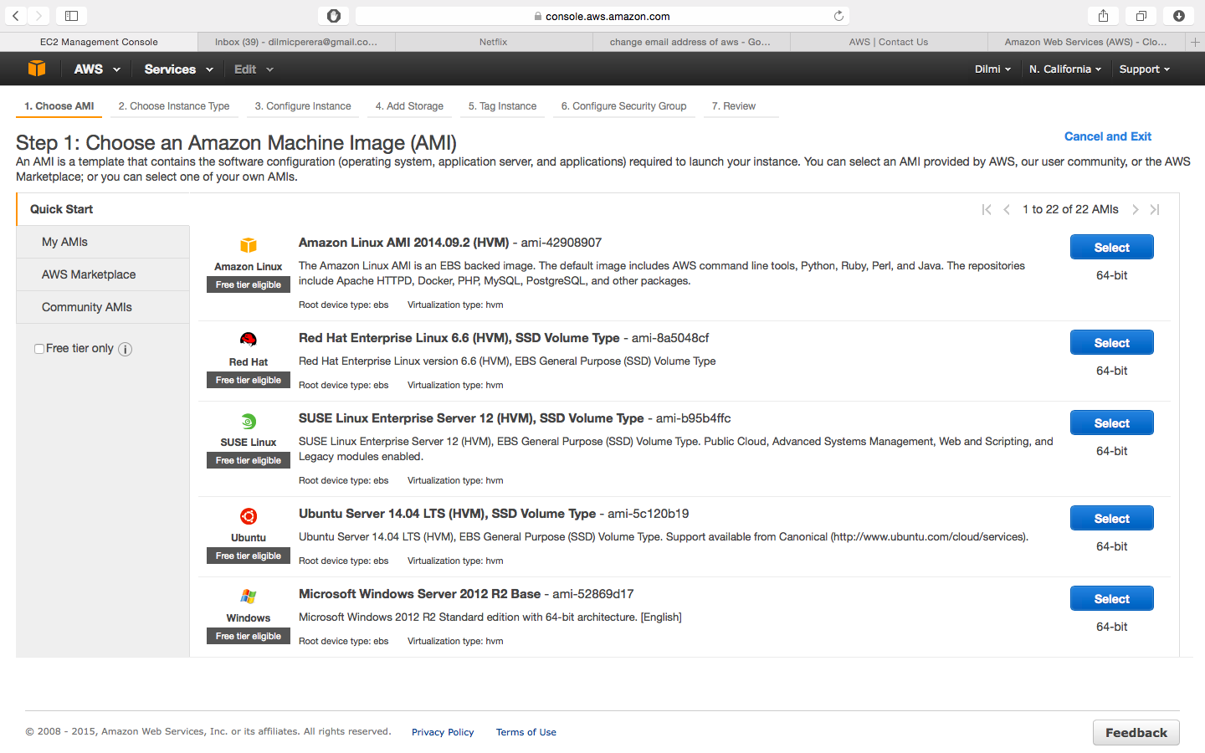

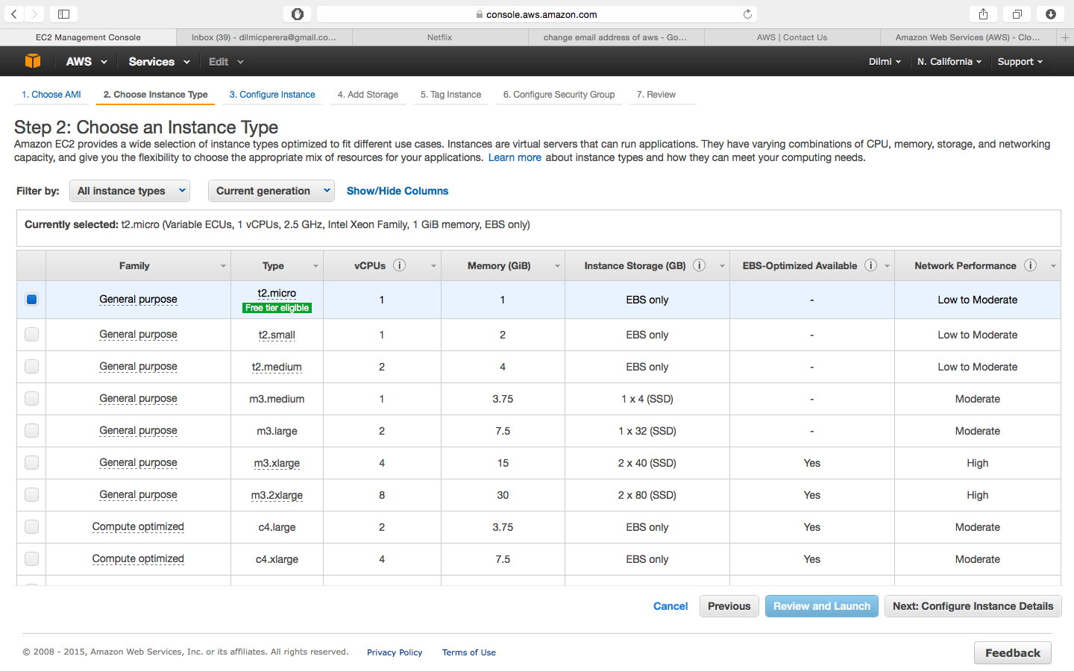

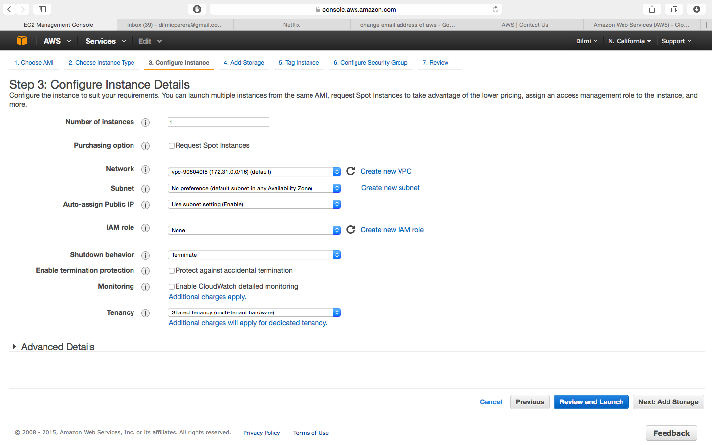

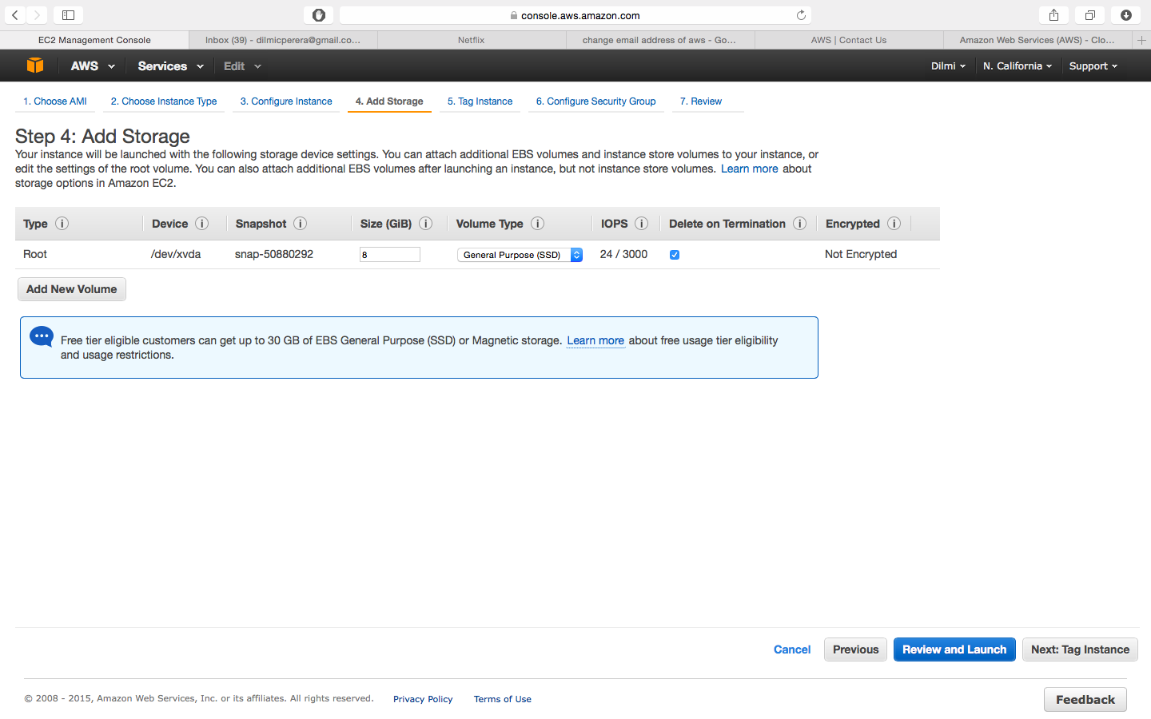

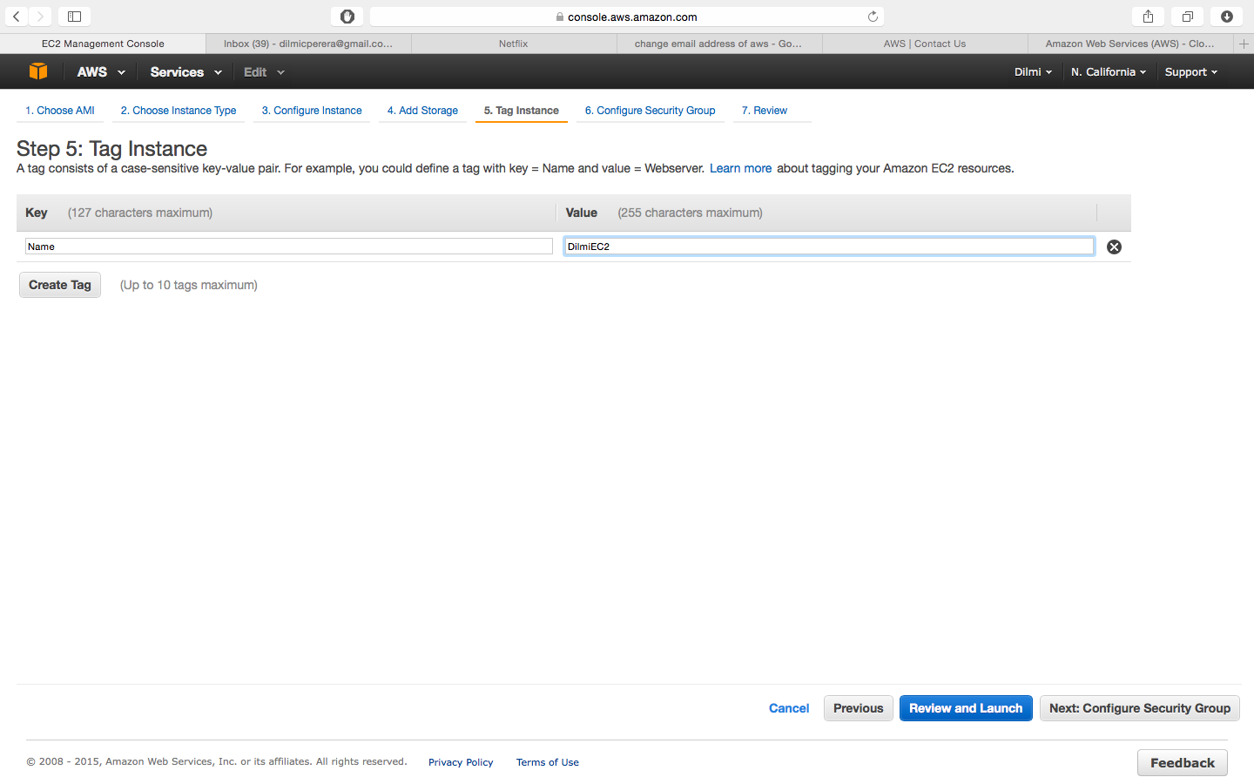

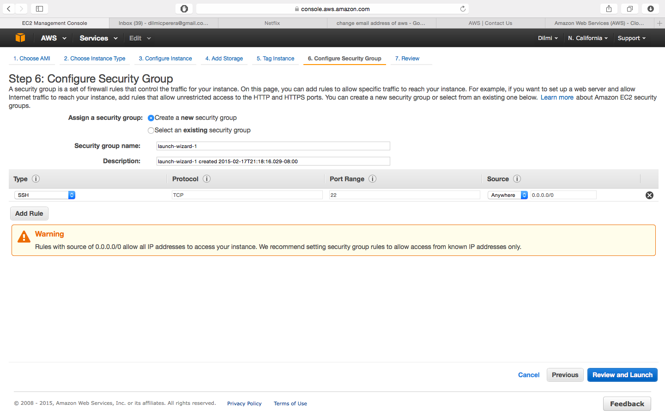

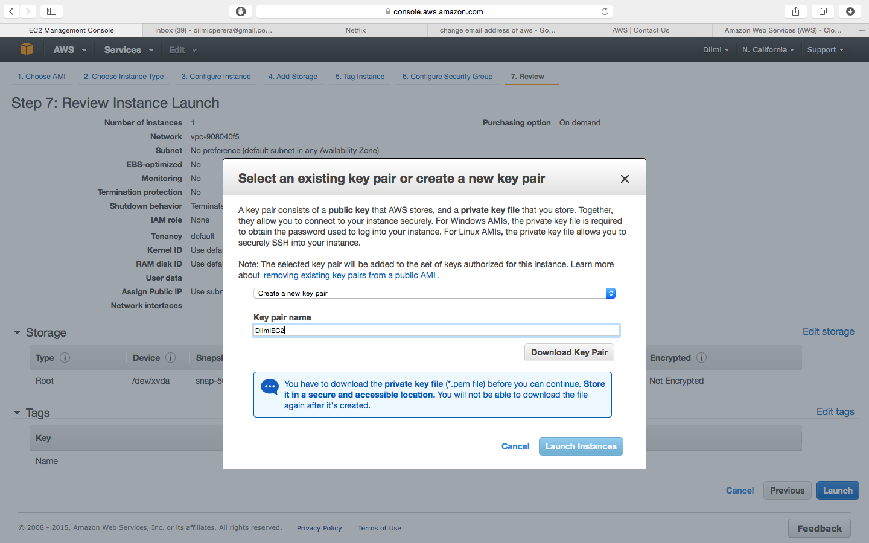

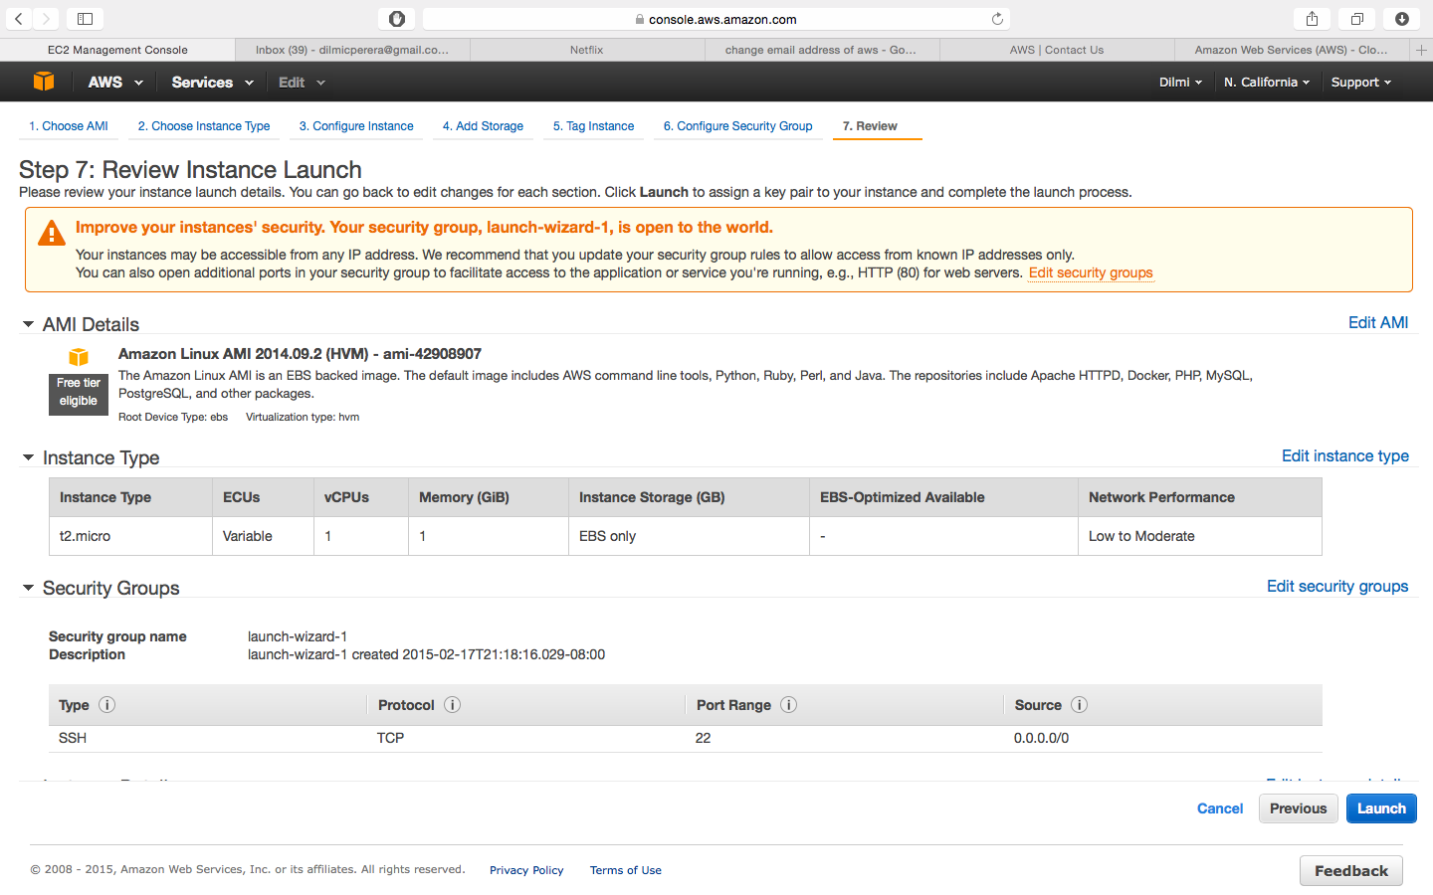

**Using SSH to connect and SCP to copy to and from AMI**

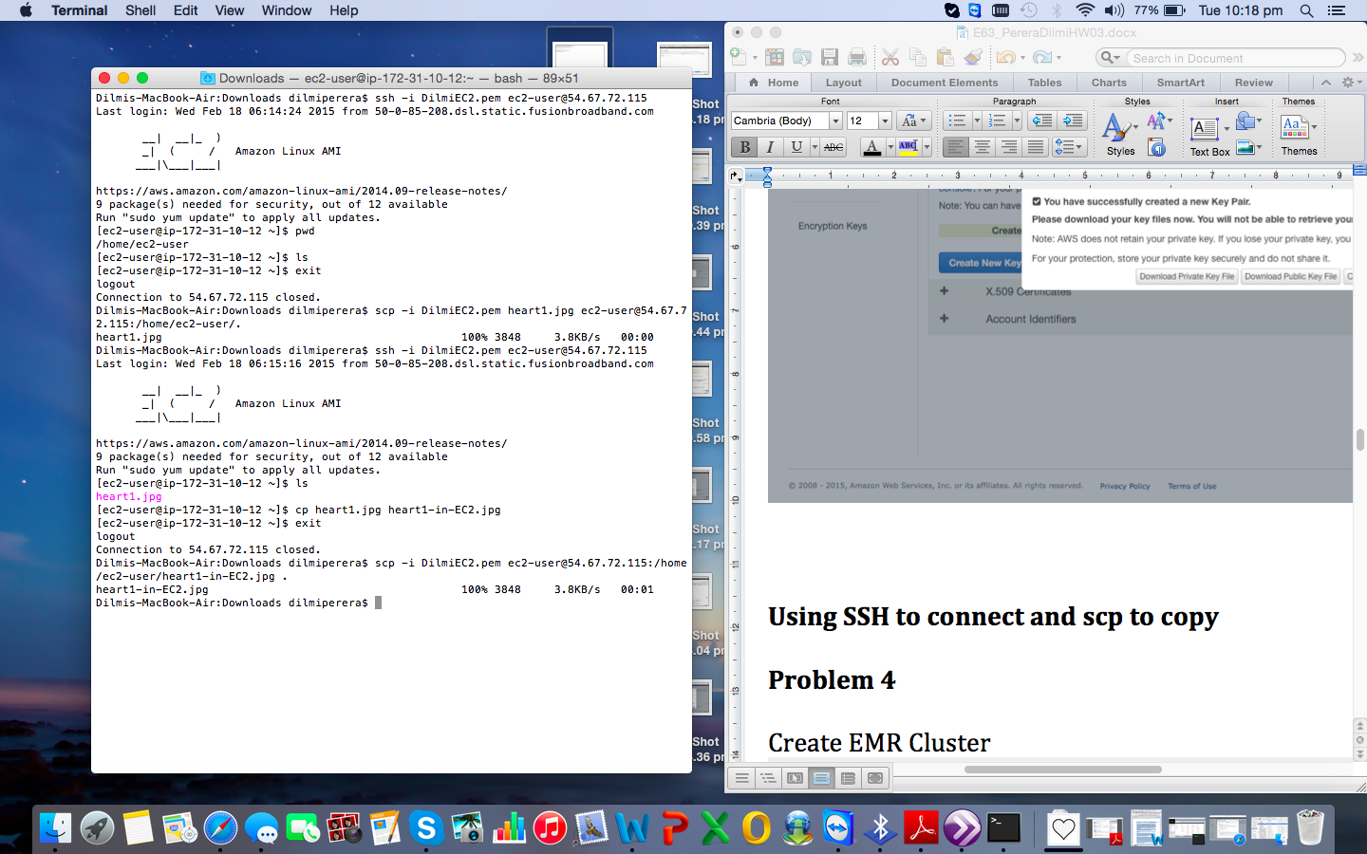

**Problem 3**

Java code: MapReduce.java.

Text file used: temp.txt

Output: WordCounts.txt

**First 5 words from program output(**WordCounts.txt**) and output from linux egrep+wc**

many 1

periodically 1

value 2

workers 4

key 5

egrep + wc

Dilmis-MacBook-Air:~ dilmiperera$ egrep -o '\<many\>' /Users/dilmiperera/Downloads/temp.txt | wc -w

1

Dilmis-MacBook-Air:~ dilmiperera$ egrep -o '\<Periodically\>' /Users/dilmiperera/Downloads/temp.txt | wc -w

1

Dilmis-MacBook-Air:~ dilmiperera$ egrep -o '\<value\>' /Users/dilmiperera/Downloads/temp.txt | wc -w

2

Dilmis-MacBook-Air:~ dilmiperera$ egrep -o '\<workers\>' /Users/dilmiperera/Downloads/temp.txt | wc -w

4

Dilmis-MacBook-Air:~ dilmiperera$ egrep -o '\<key\>' /Users/dilmiperera/Downloads/temp.txt | wc -w

5

**Problem 4**

Create EMR Cluster

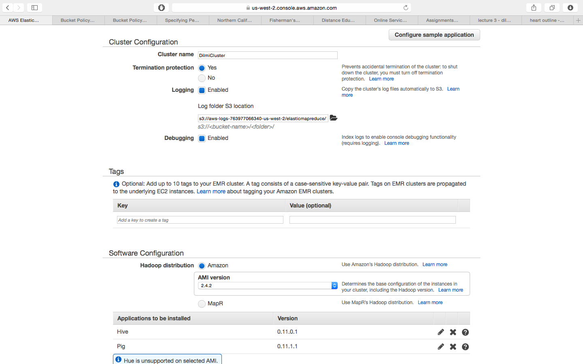

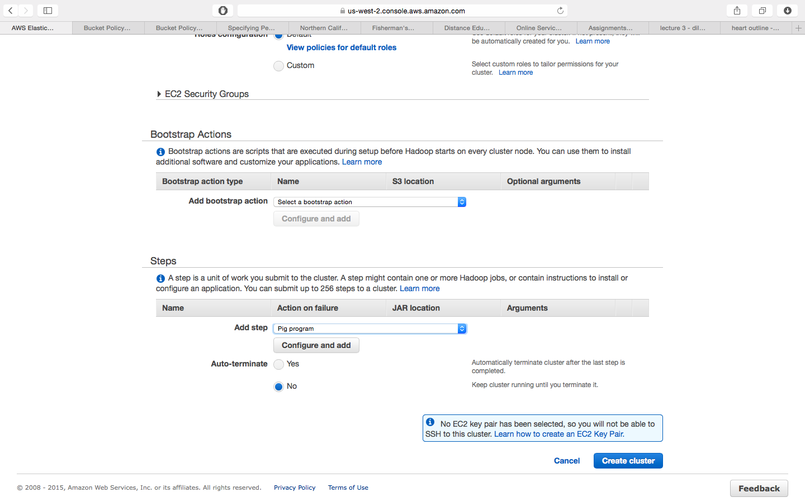

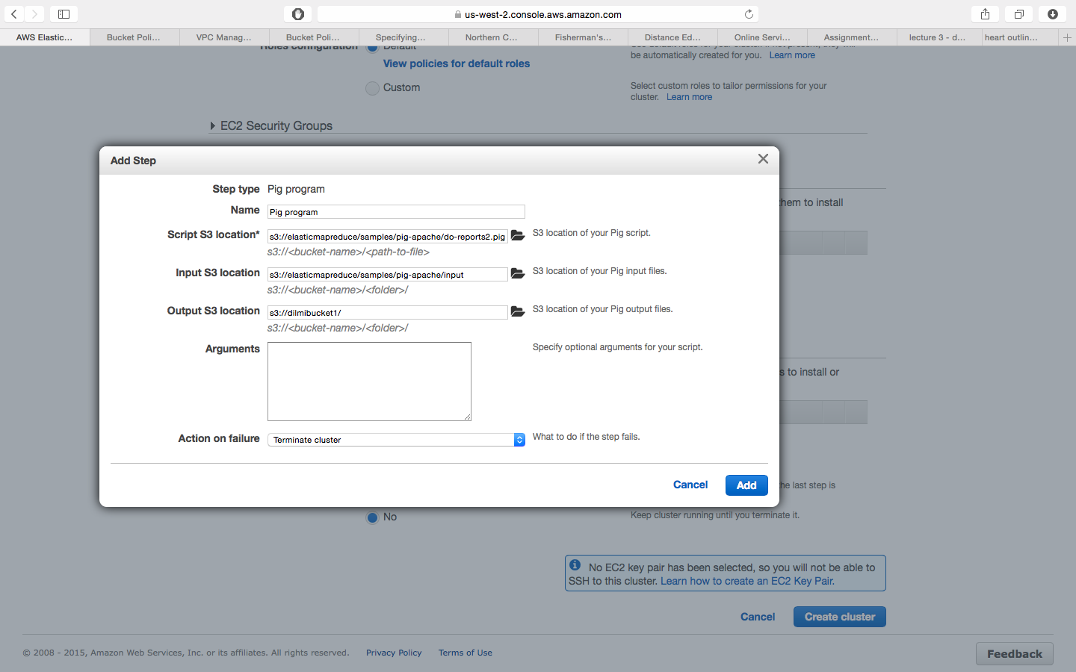

Starting and running cluster

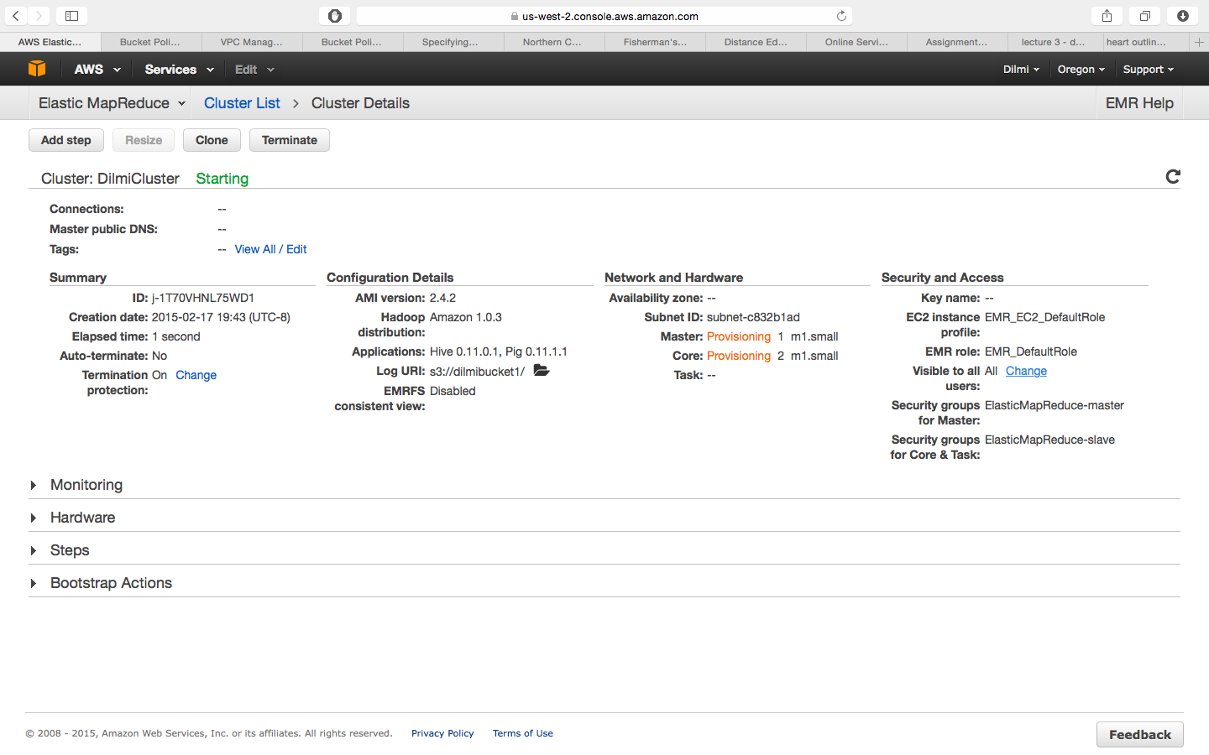

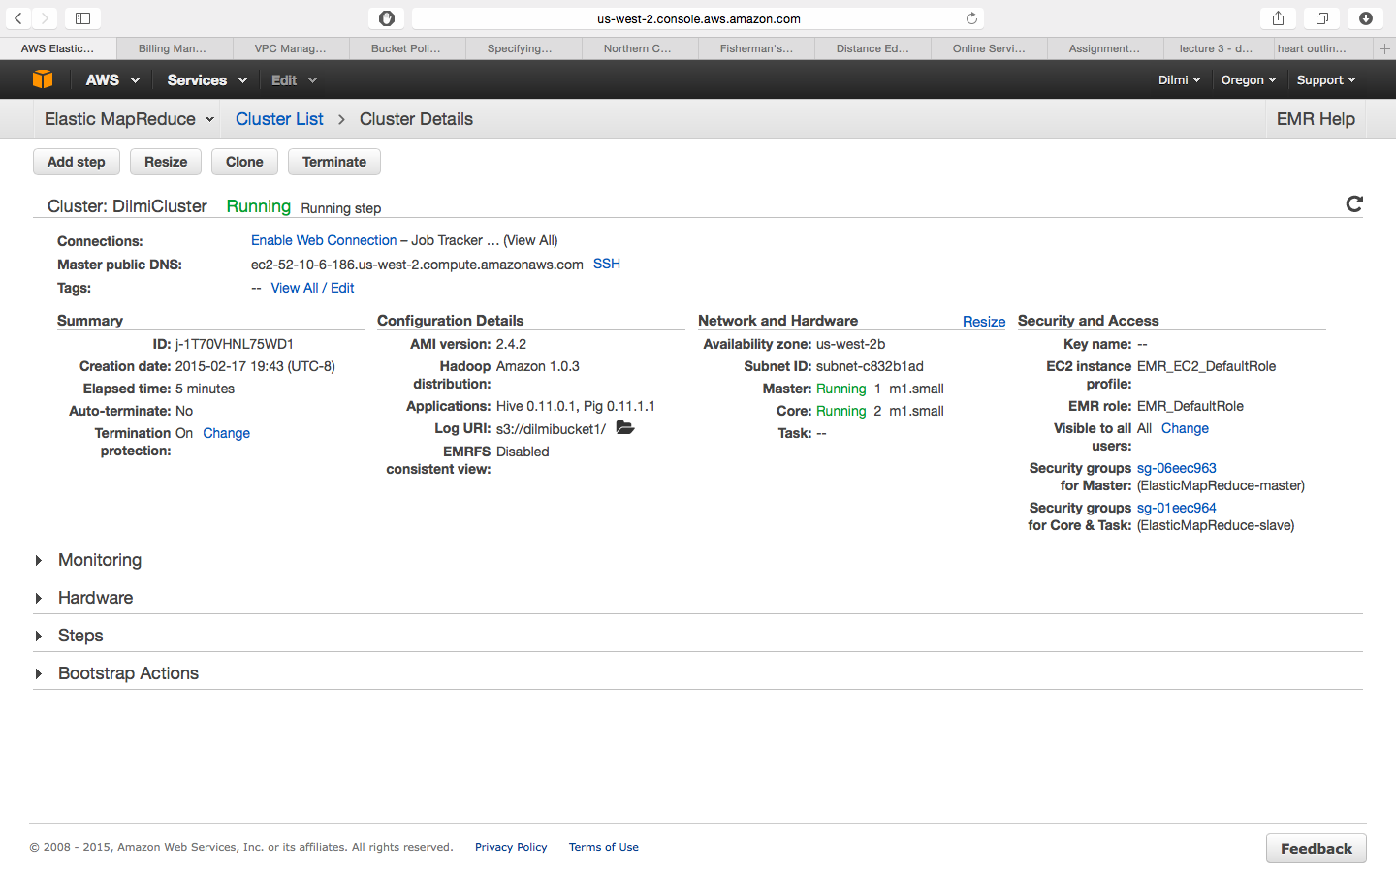

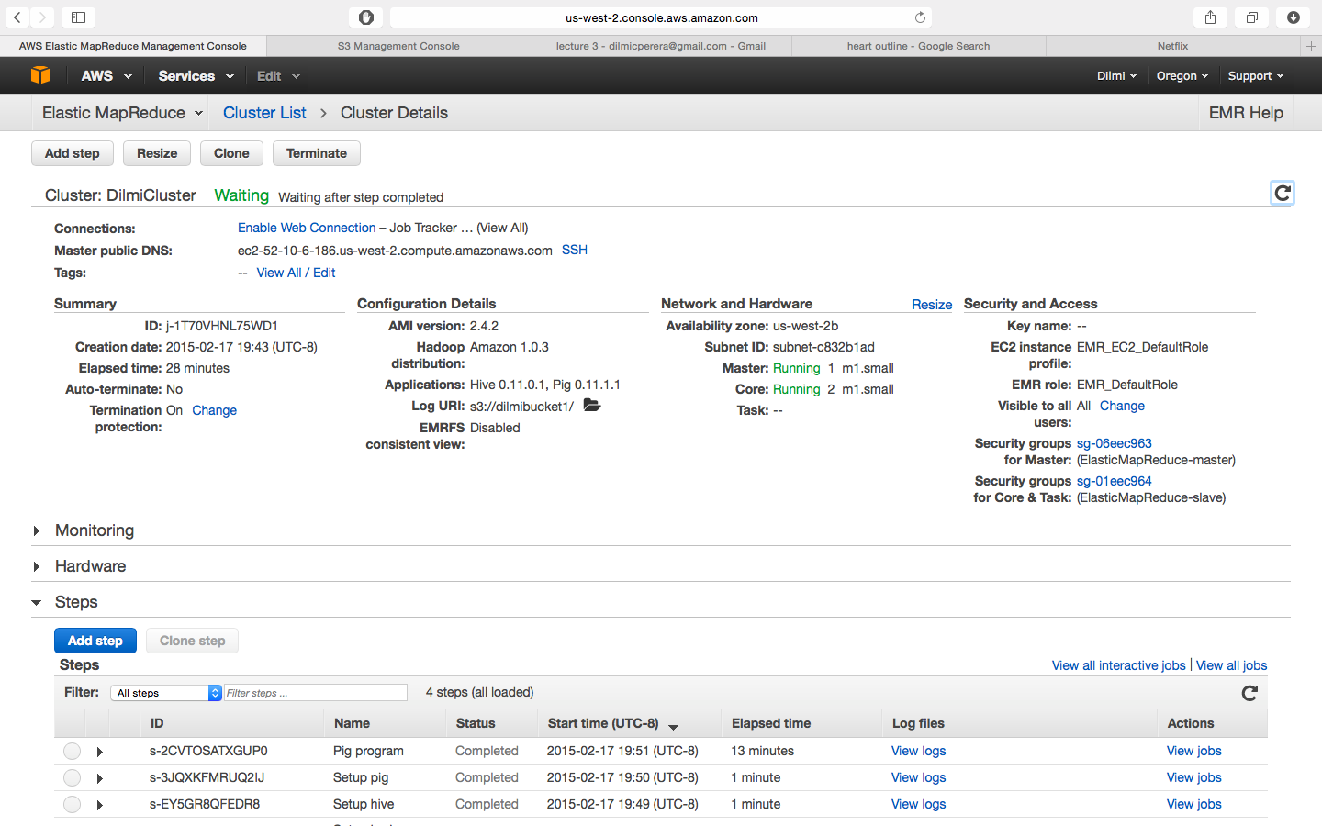

Results

